BIT 4107 – Mobile Application Development
ENHANCED PROFESSIONAL STUDENT LOGBOOK
Student Name: NOELLE BLESSING
Admission Number: BIT/2024/73309
School/Faculty: SCHOOL OF COMPUTING AND INFORMATICS
Programme: MOBILE APPLICATION AND DEVELOPMENT
Academic Year: YEAR 3
Semester: SEMESTER TWO
Lecturer: MICHAEL NYORO
Phone Number: 0703358067

Instructions
This logbook is used to document weekly learning activities, practical exercises, skills acquired, challenges encountered, solutions applied, and reflections. Students should complete all sections every week.
Each week to follow remarks in week 1 section.

Week 1: Introduction to Mobile Application Development

Practical Activities Undertaken
Figure 1: VS Code open showing Welcome screen and GitHub Copilot panel
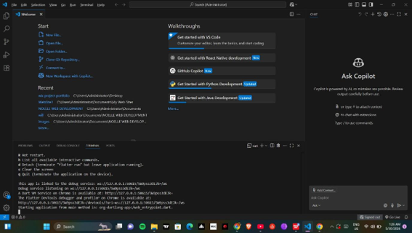

Figure 2: Flutter SDK folder structure in File Explorer
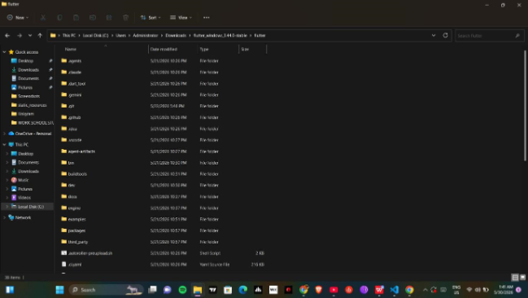
Figure 3: Flutter doctor showing green ticks — Flutter, Android toolchain, Chrome and Connected devices all working
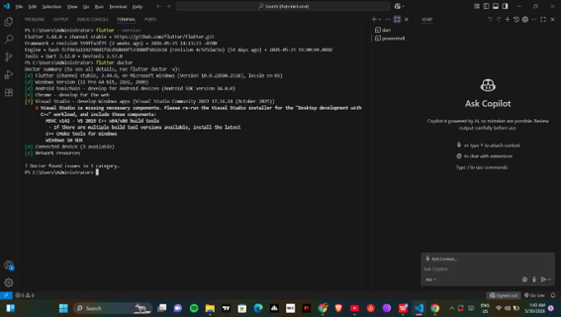

Figure 4: Default Flutter app running on Chrome — showing counter button functionality
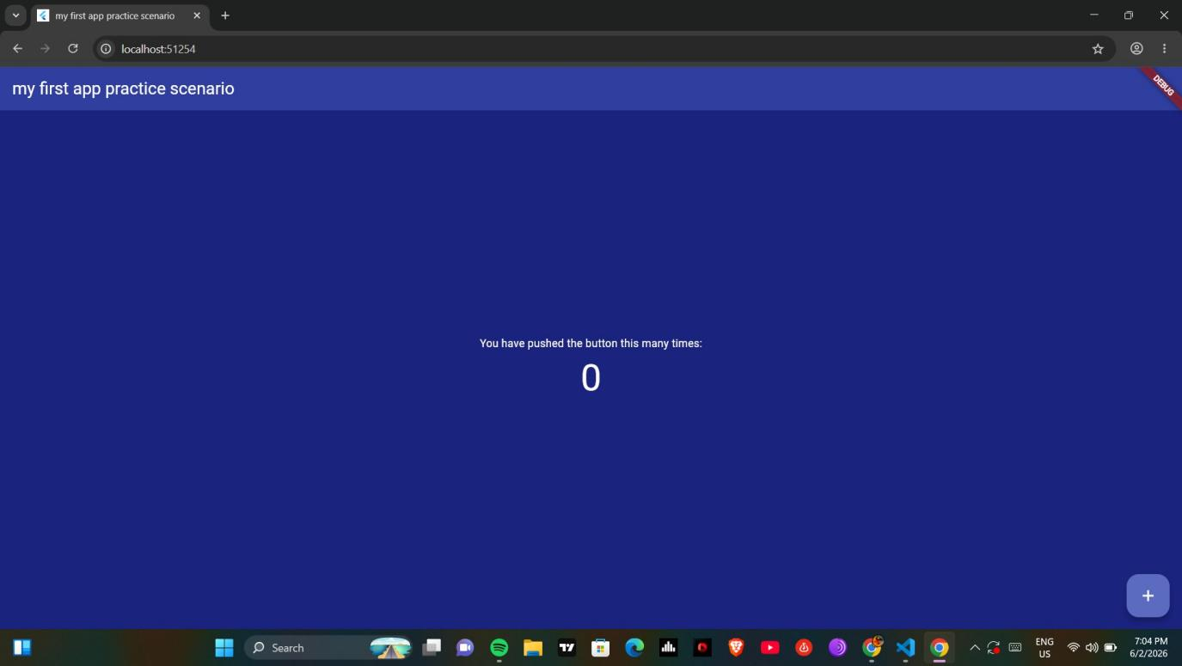
Figure 5: App title changed to ‘my first app practice scenario’ — visible in browser tab and app header
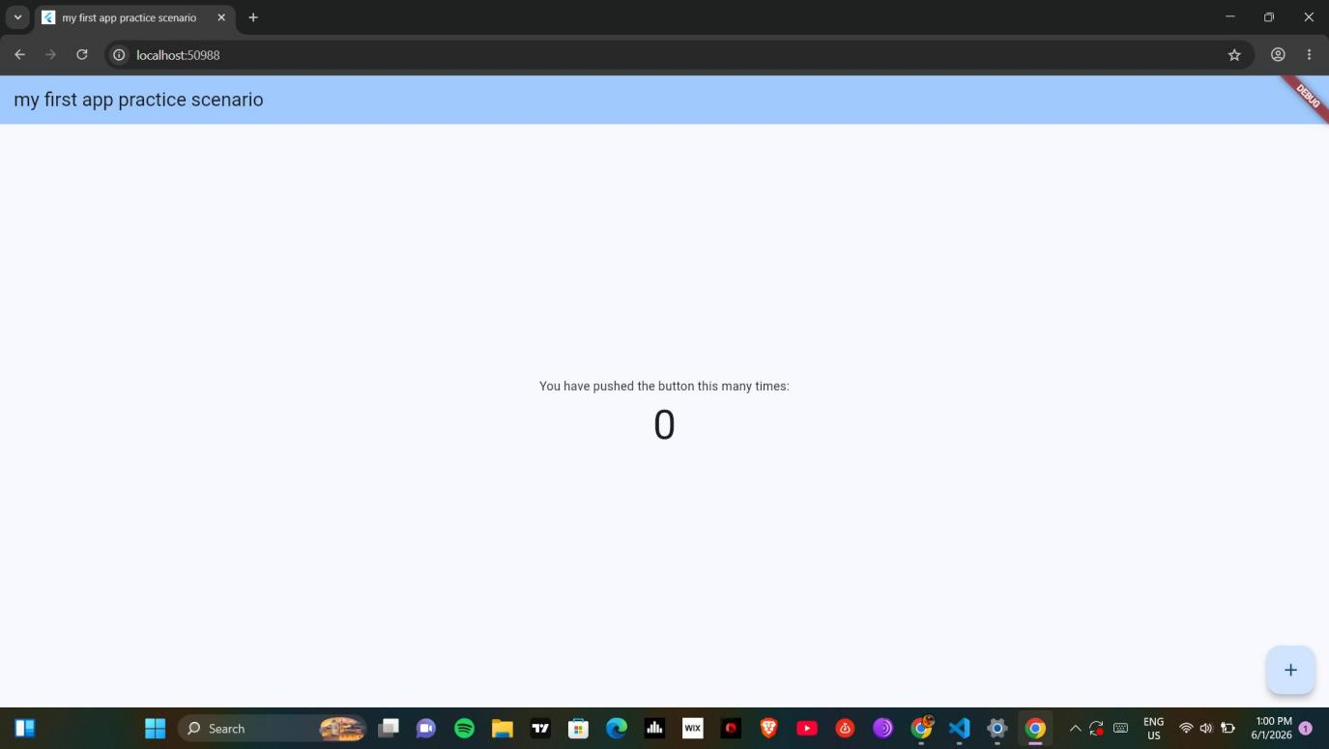

Figure 6: Background color changed to blue
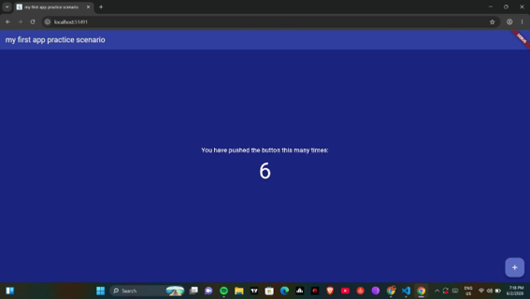
Screenshots/Evidence Attached: Yes

Tools/Software Used
Visual Studio Code (VS Code), Flutter SDK v3.44.0 (Dart), Android SDK v34.0.0, Git, Node.js, Python, GitHub Copilot, Chrome Browser (as emulator)

Personal Reflection
Week 1 involved setting up the full mobile development environment using VS Code and Flutter SDK. Despite PATH configuration challenges with Flutter and Android SDK, all tools were successfully installed. A first Flutter app was created, run on Chrome, and customized with a new title, background color, and font size.

Week 2: Mobile Development Environment

Practical Activities Undertaken
Figure 1: Login screen showing form validation errors on empty submission
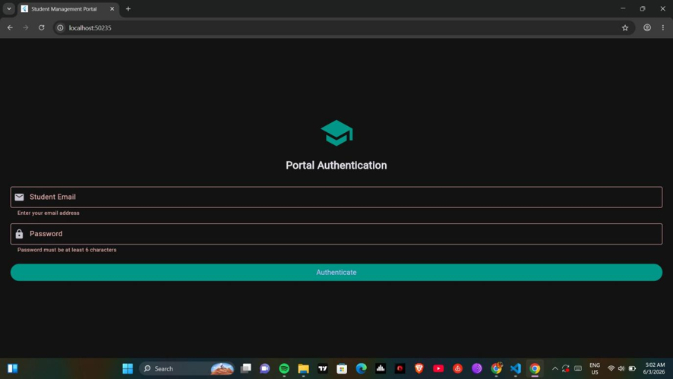
Figure 2: Student Registry screen showing empty state before any records are added
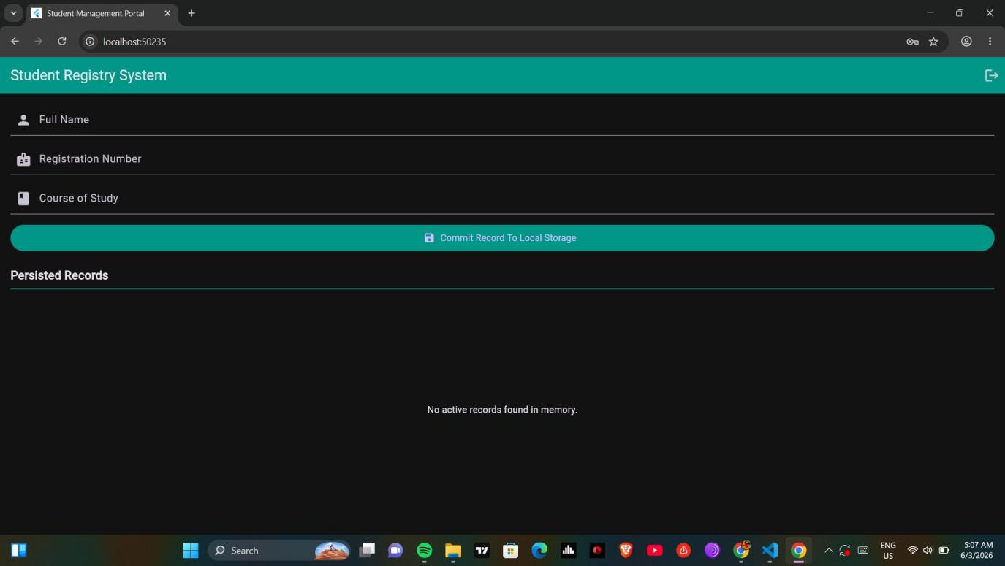
Figure 3: Student record saved — showing NOELLE, INFORMATION TECHNOLOGY | BIT/2024/73309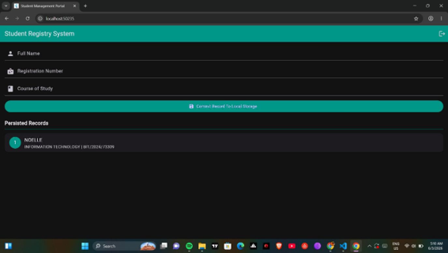

Screenshots/Evidence Attached: Yes

Tools/Software Used
Visual Studio Code (VS Code), Flutter SDK (Dart), Chrome Browser (as emulator)

Personal Reflection
Week 2 involved building a Mini Student Management App with login, form validation, multi-screen navigation, and in-memory record storage using Flutter. Challenges with state management and form validation were resolved using StatefulWidget and GlobalKey. The dark teal theme gave the app a professional finish.

Week 3: User Interface Design

Practical Activities Undertaken

Figma Wireframe — Screen 1: Authentication / Login
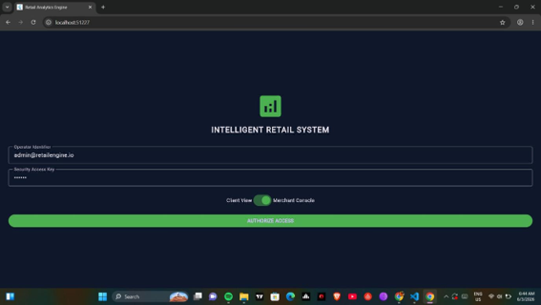

Figma Wireframe — Screen 2: Live Market Cata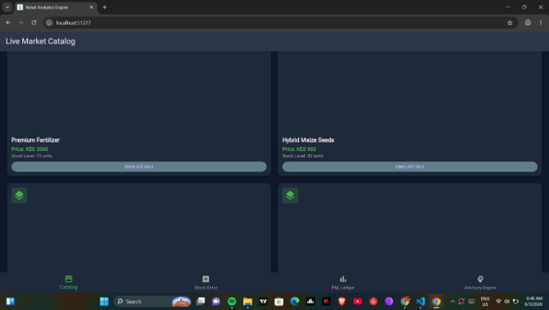

Figma Wireframe — Screen 3: Inventory Input Control
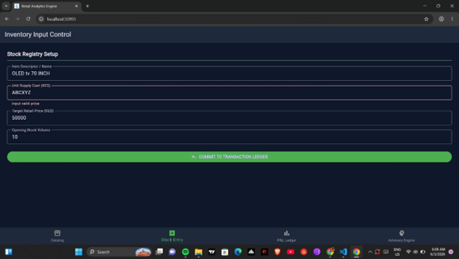
Figma Wireframe — Screen 4: Real-Time P&L Dashboard
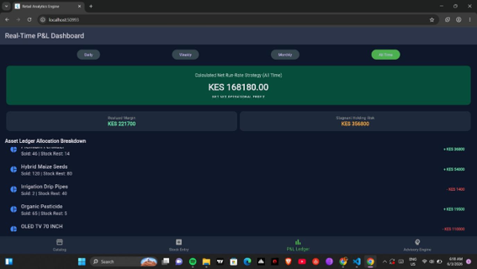
Figma Wireframe — Screen 5: Intelligent Optimization Advisory
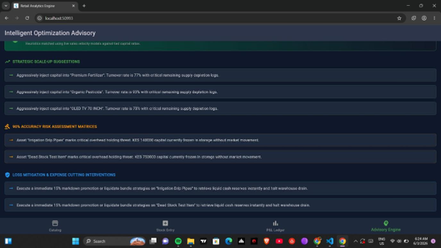

Real Device Test — Screen 1: Authentication (Android)

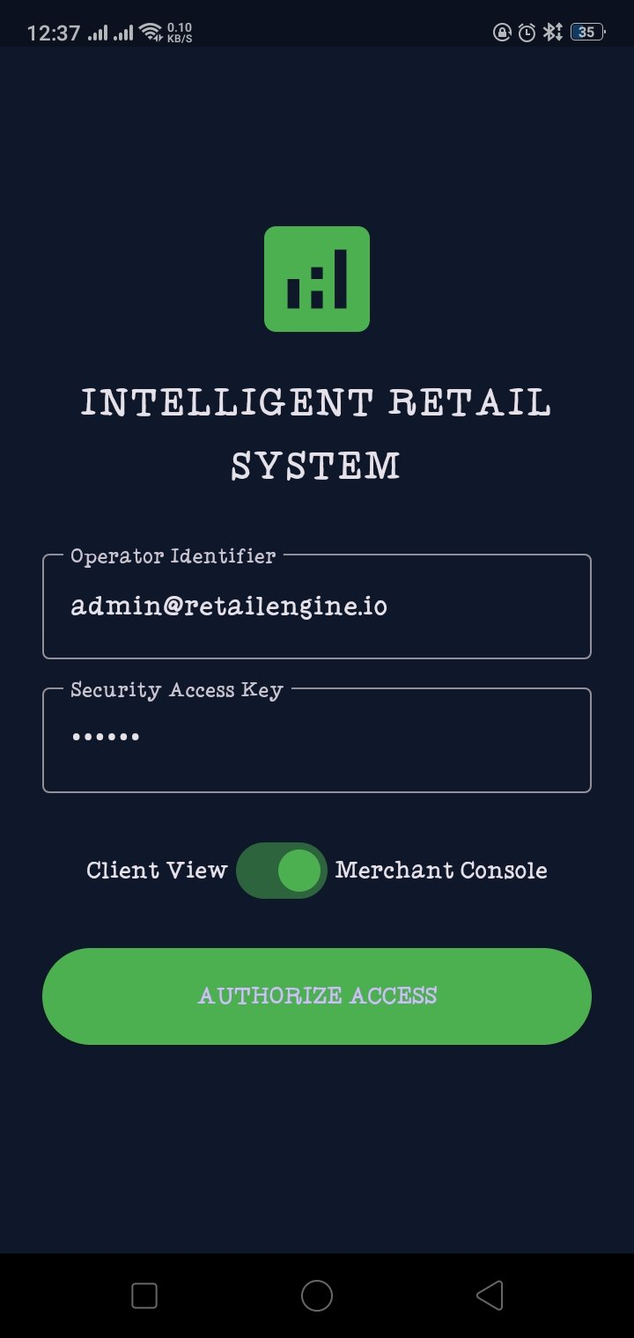

Real Device Test — Screen 2: Live Market Catalog (Android)

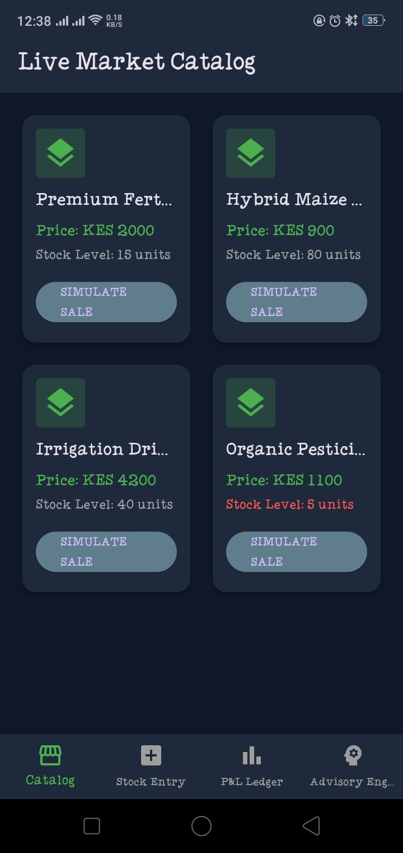

Real Device Test — Screen 3: P&L Dashboard (Android)

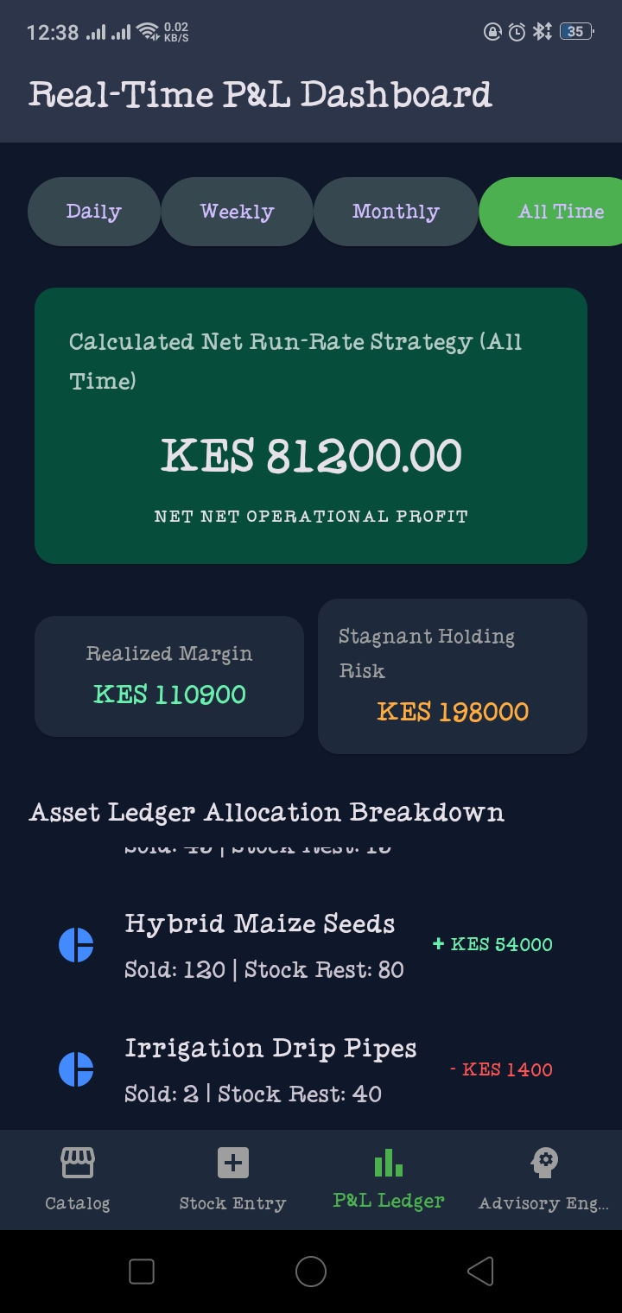

Real Device Test — Screen 4: Intelligent Advisory Engine (Android)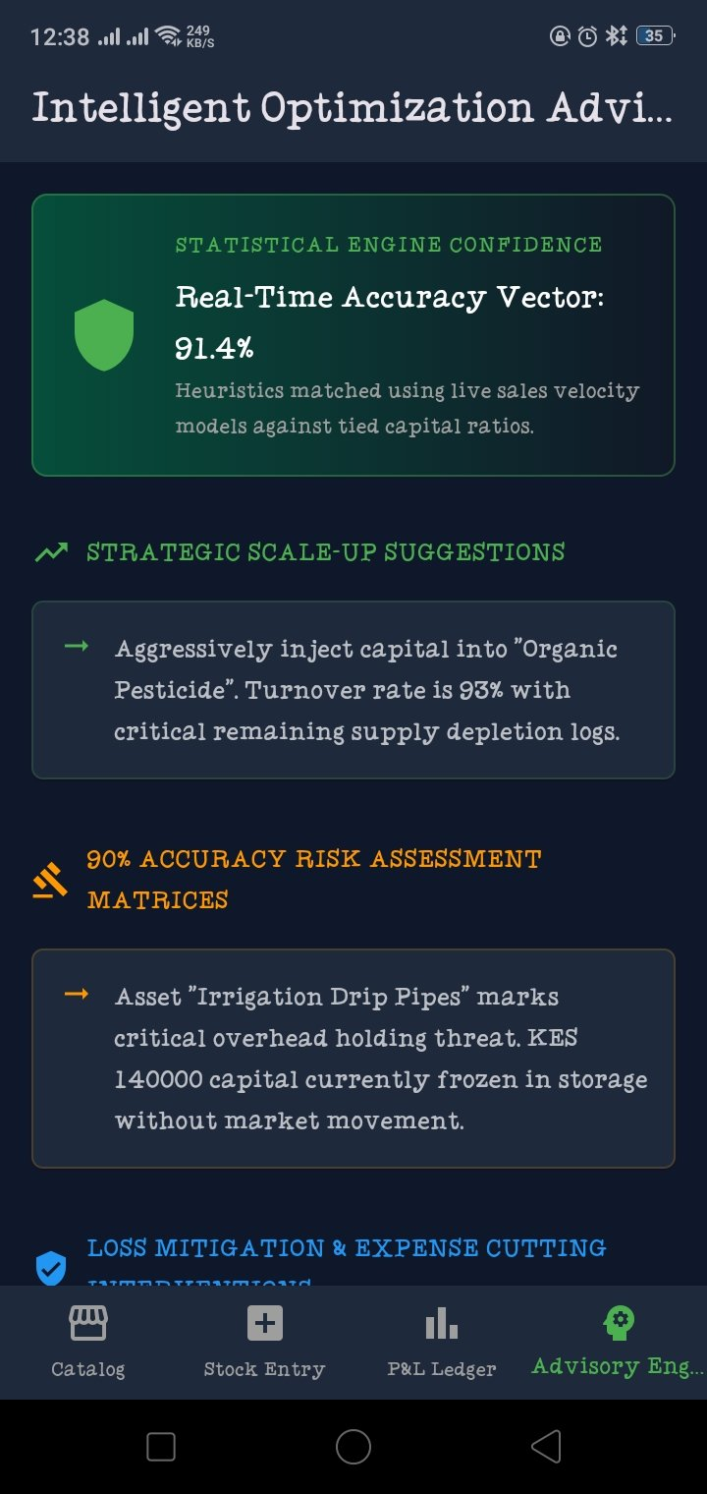
Screenshots/Evidence Attached: Yes

Tools/Software Used
Visual Studio Code (VS Code), Flutter SDK (Dart), Figma (UI wireframing), Android device (real device testing via USB debugging), Chrome Browser

Personal Reflection
Week 3 involved building a full 5-screen Intelligent Retail Analytics Engine addressing real business needs in Thika, Kenya. Key concepts covered included responsive GridView layouts, bottom navigation, global state management, Dart getters for profit/loss calculations, and deploying to a real Android device for testing.

Week 4: Event Handling and User Interaction

Same as week 1

Week 5: Data Management

Same as week 1

Week 6: Networking and APIs

Same as week 1

Week 7: Application Architecture

Same as week 1

Week 8: Project Planning

Week 9: Device Features and Sensors

Same as week 1

Week 10: Notifications and Background Services

Same as week 1

Week 11: Mobile Security

Same as week 1

Week 12: Testing and Debugging

Same as week 1

Week 13: Application Deployment

Same as week 1

Week 14: Final Project Presentation

Same as week 1

Semester Project Tracking

Project Title

Project Objectives

Project Requirements

Development Milestones

Testing Results

Lessons Learned

Future Improvements

End of Semester Reflection

Summary of Skills Acquired

Most Interesting Topic

Major Challenges Faced

How Challenges Were Overcome

Professional Growth Achieved

Overall Course Experience

Final Approval
Student Name: __________________________
Student Signature: ______________________
Date: _________________________________
Lecturer Name: _________________________
Lecturer Remarks: _____________________
Date: _________________________________

